Question 1: Product Order Calculator
Part 1: Display Available Products. (Marks 1)
1. Create a JavaScript array containing product objects with id, name, category, price, and stock.
2. Use a loop and condition to display only the products whose stock is greater than 0.
3. Attach a screenshot of the JavaScript code.
JavaScript Code:
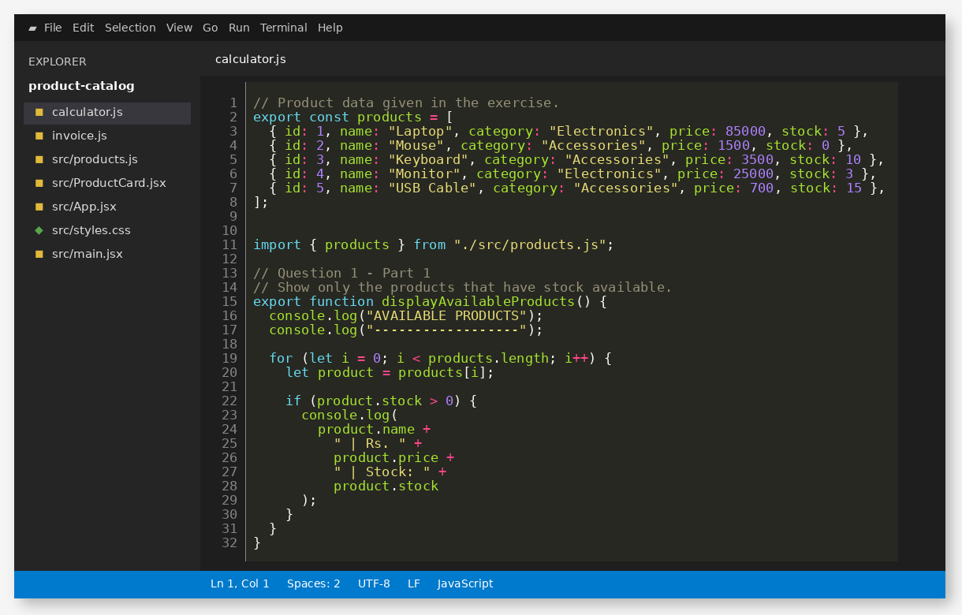

Part 2: Calculate Order Totals. (Marks 2)
1. Create sample cart items containing a product id and quantity.
2. Calculate the subtotal by multiplying each product price by its quantity.
3. Apply a 10% discount when the subtotal is greater than Rs. 50,000.
4. Calculate the final total after discount.
5. Attach a screenshot of the calculation code.
JavaScript Code:
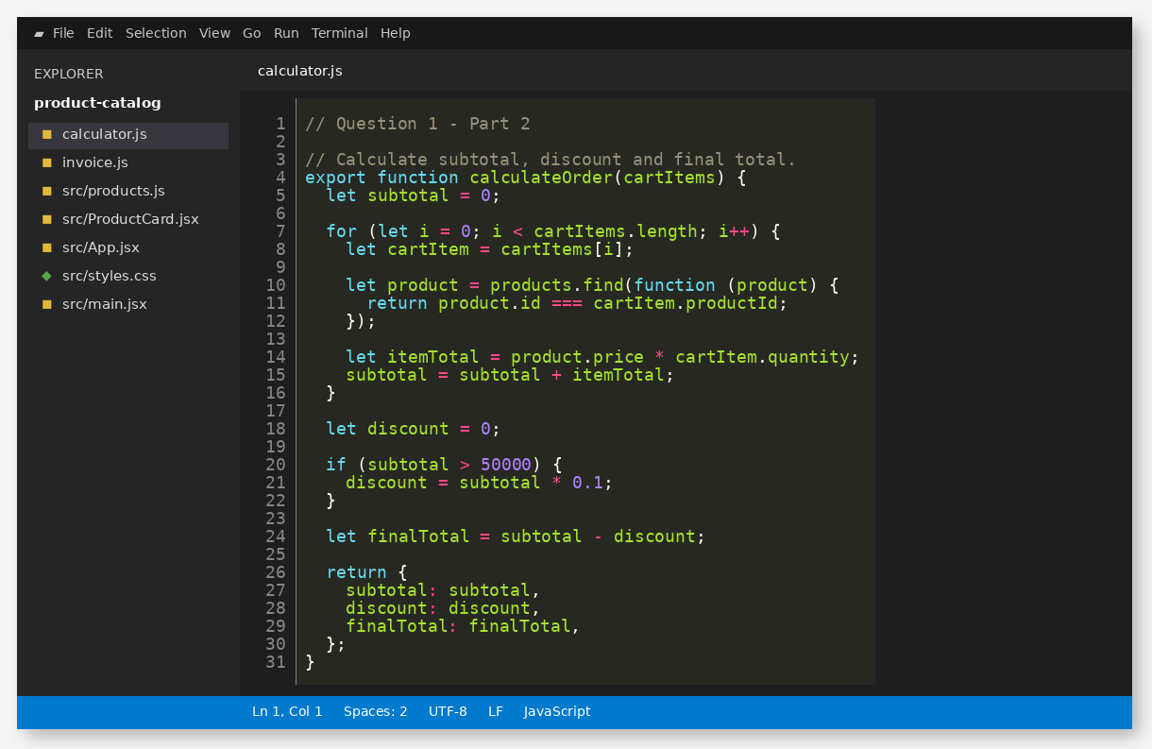

Part 3: Display the Product Order Invoice. (Marks 2)
1. Display each selected product with quantity, unit price, and item total.
2. Display the subtotal, discount, and final total clearly.
3. Attach screenshots of the invoice code and program output.
JavaScript Code and Sample Cart:
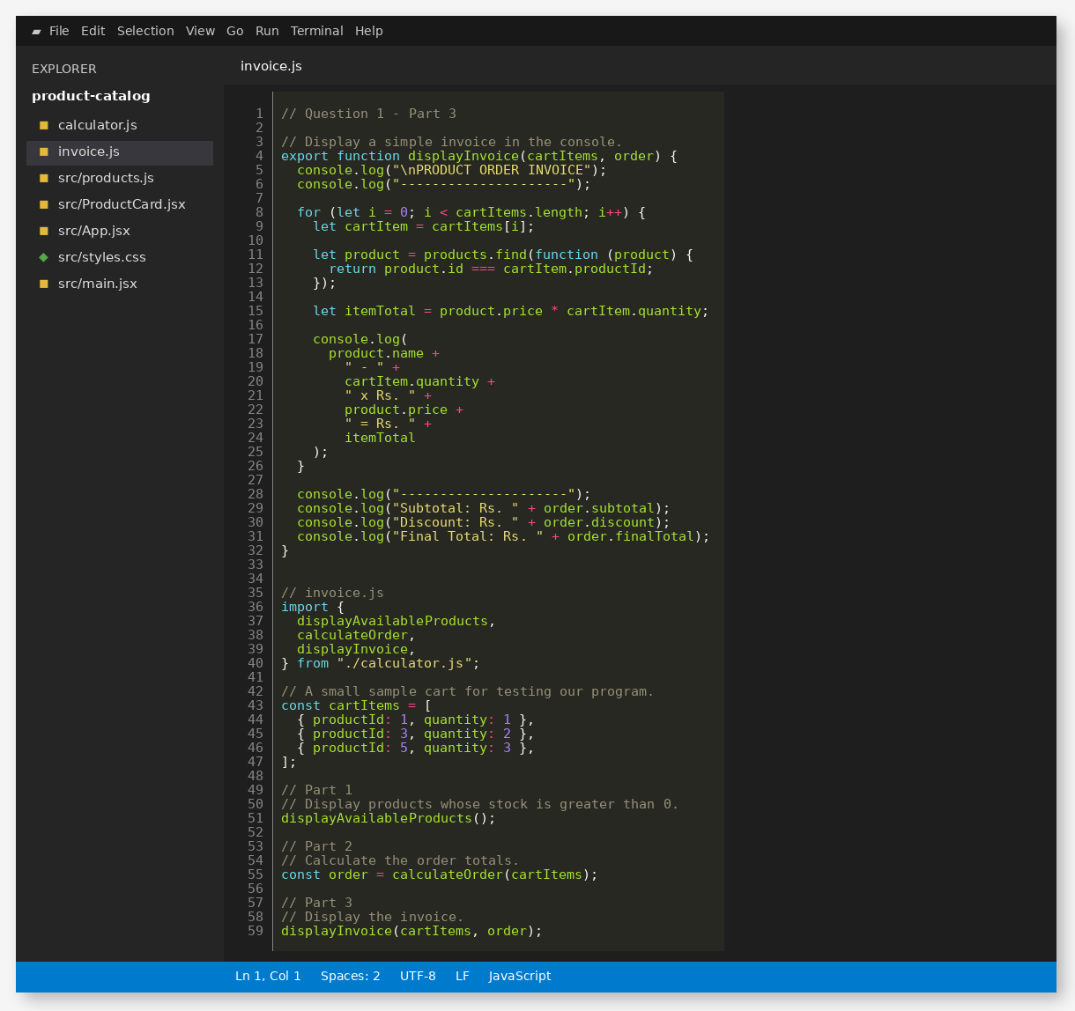

Program Output:
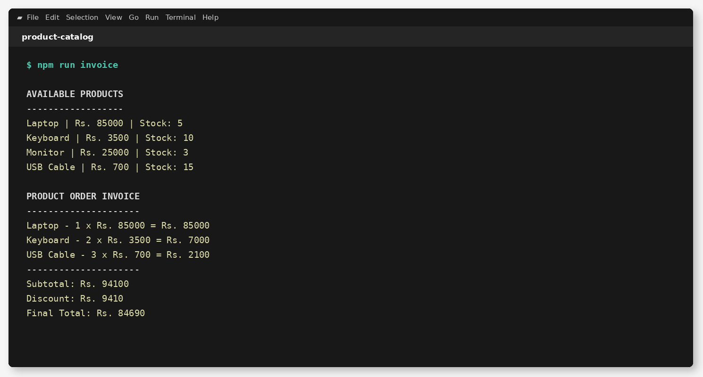

Question 2: React Product Catalog
Part 1: Create the React Project and ProductCard Component. (Marks 2)
1. Create a React project using Vite and configure the React entry point.
2. Create a reusable ProductCard component using props.
3. Display product name, category, price, and stock status.
4. Add an Add to Cart button and disable it when stock is 0.
5. Attach screenshots of the project setup and ProductCard code.
Vite Project Setup:
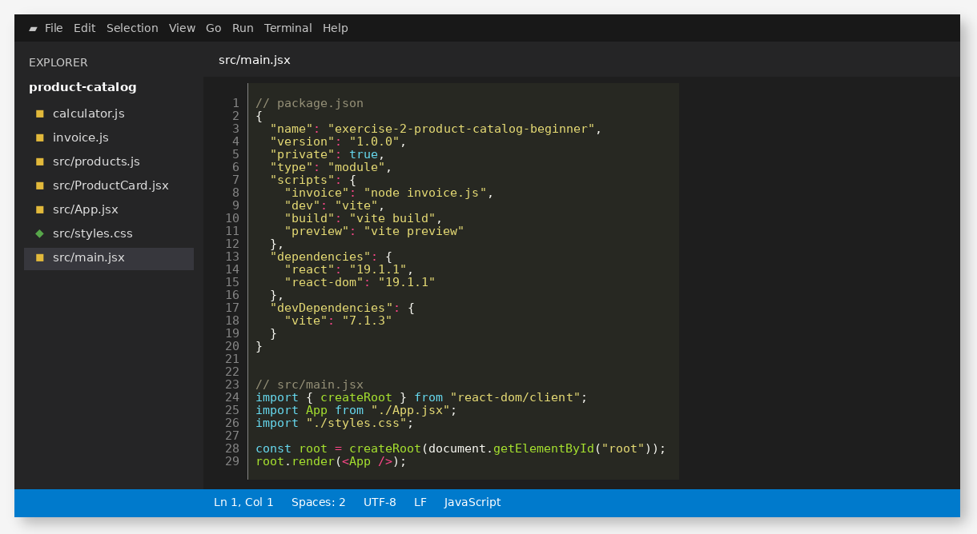

ProductCard Component:
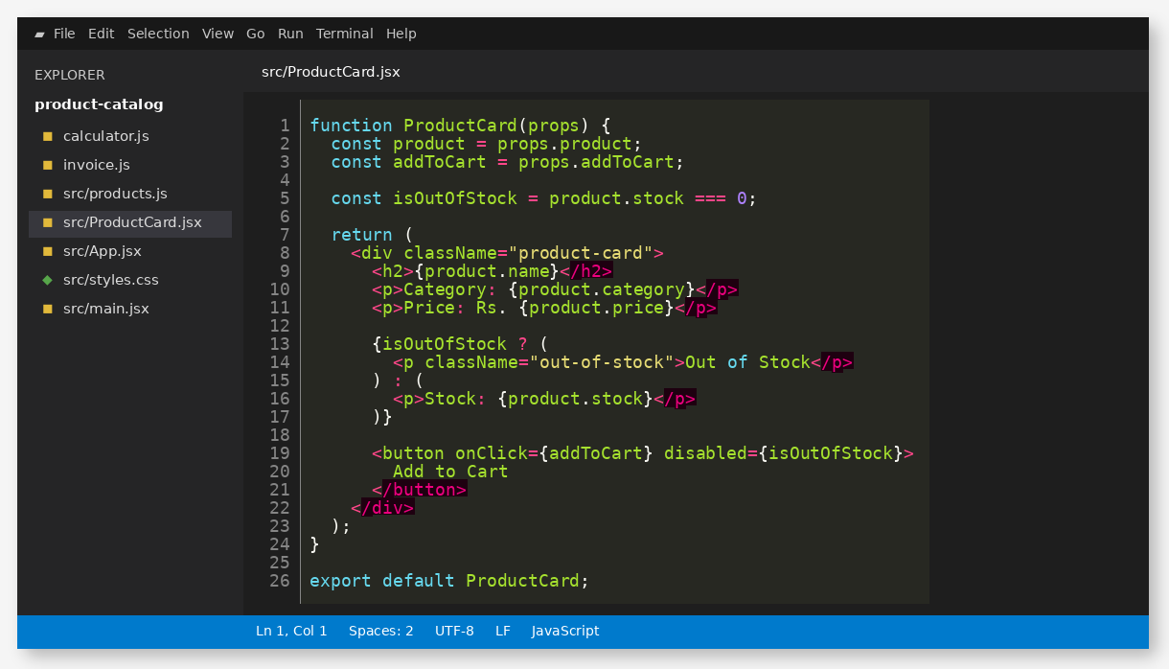

Part 2: Render the Product Array and Apply Responsive Styling. (Marks 2)
1. Store at least four products in an array and render them as ProductCard components.
2. Use the map() function to create the product cards.
3. Use CSS Grid for the catalog layout.
4. Make the catalog responsive for desktop, tablet, and mobile screen sizes.
5. Attach screenshots of the React code, CSS code, and browser output.
React Code using map():
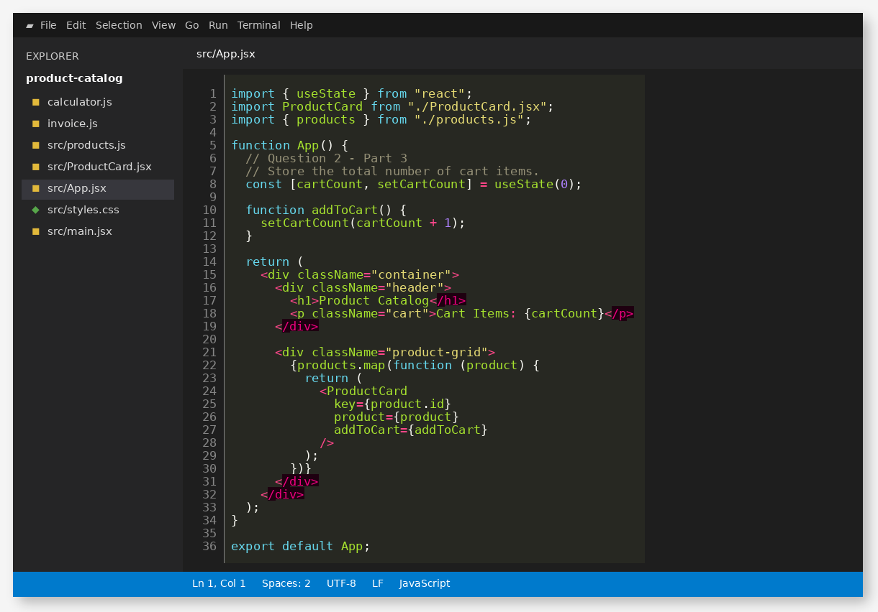

CSS Code:
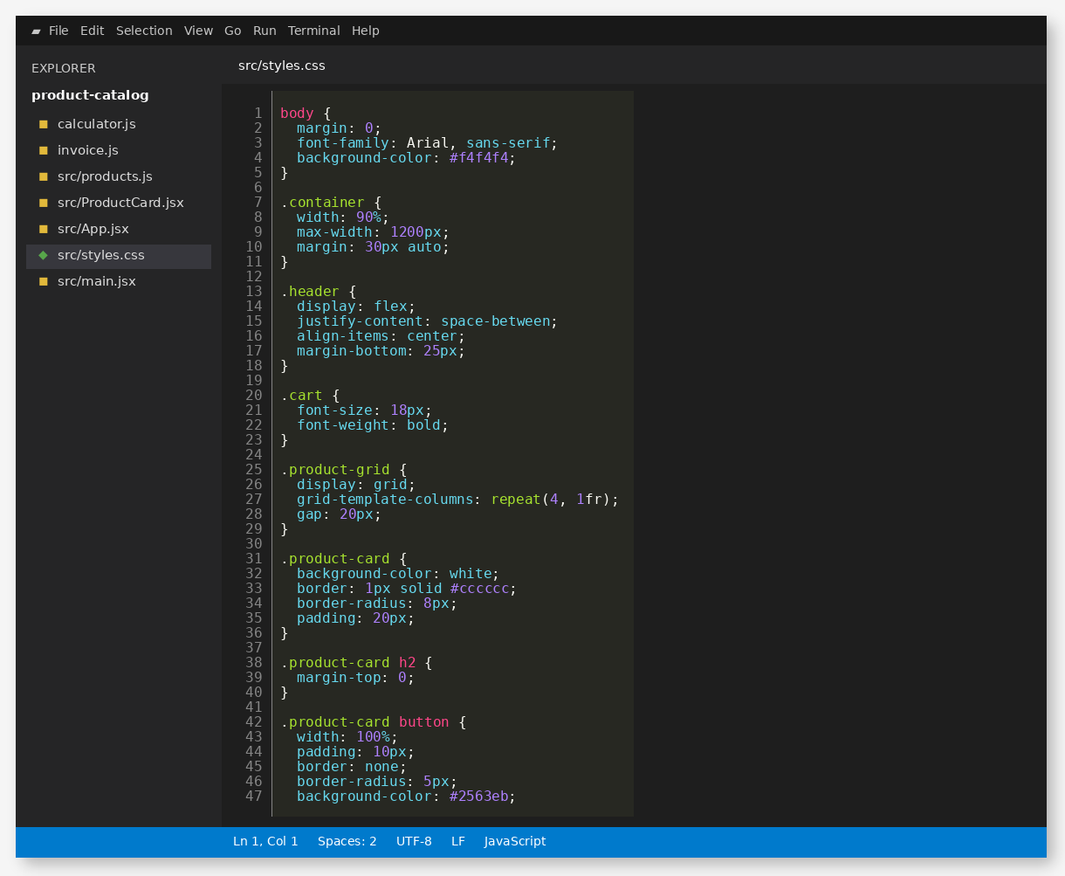

Responsive CSS:
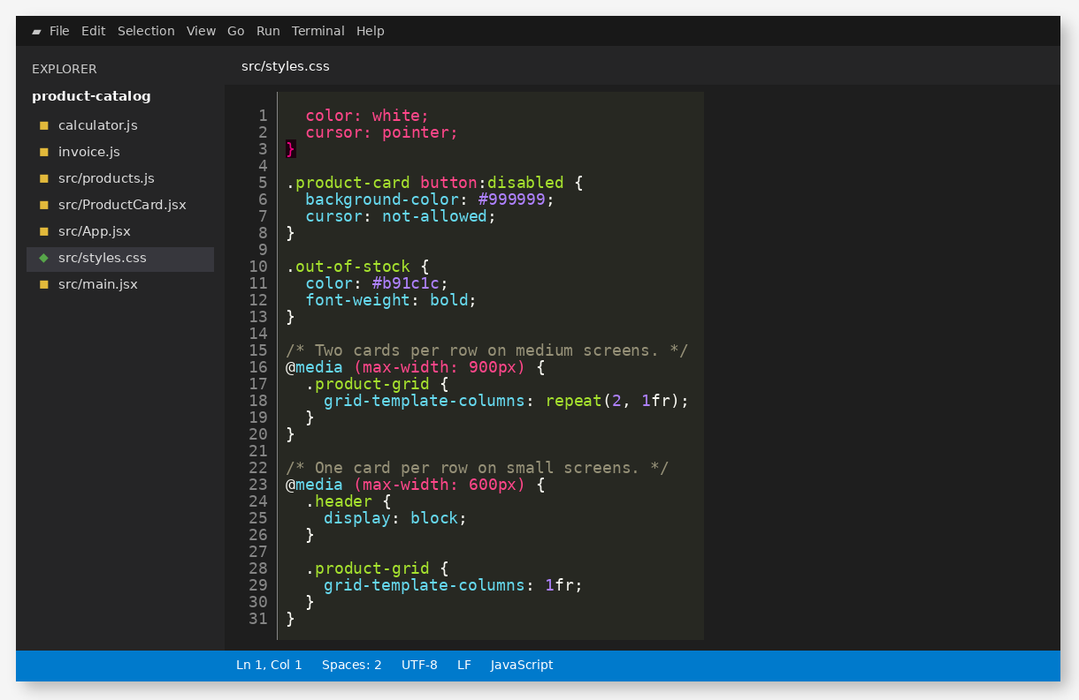

Browser Output:
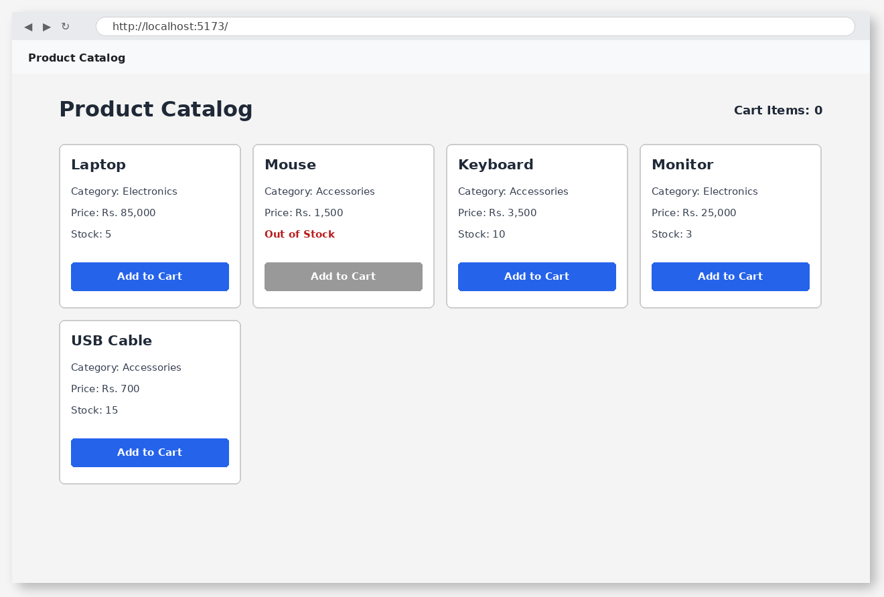

Part 3: Track Cart Items using React State and Events. (Marks 1)
1. Use useState() to store the total number of items added to the cart.
2. Create an Add to Cart click event that increases the cart count by 1.
3. Display the current cart count on the page.
4. Attach screenshots of the state/event code and the updated browser output.
React State and Event Handling:
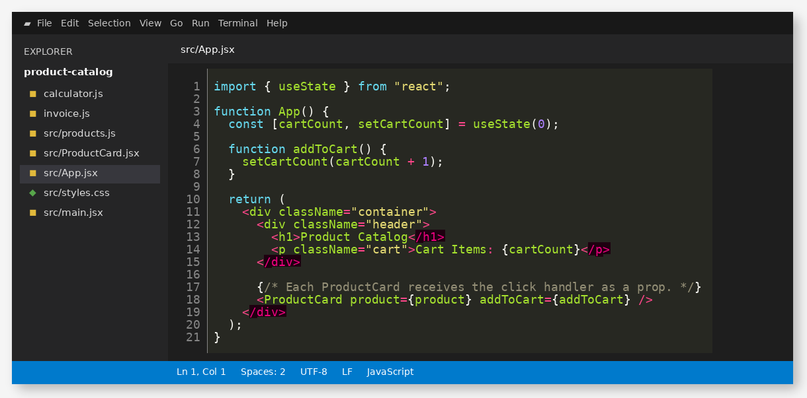

Updated Browser Output:
